1. Let’s create Step Definition file to automate each and every line inside feature file (Given, When, Then) 🡺 Login.feature.
2. Step Definition file should go under src/test/java package director.
3. Let’s create StepDefinition.java under a new **package stepDefinitions**.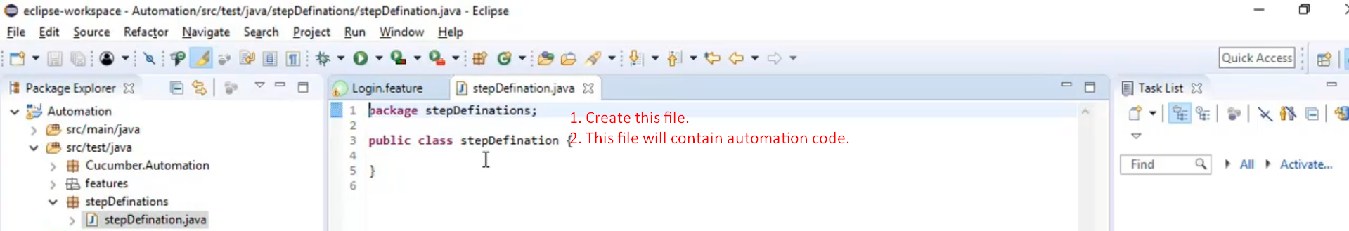
4. In this class, we will define some methods which will be mapped to each step in BDD Scenario (Given, When, Then, And, But).
5. 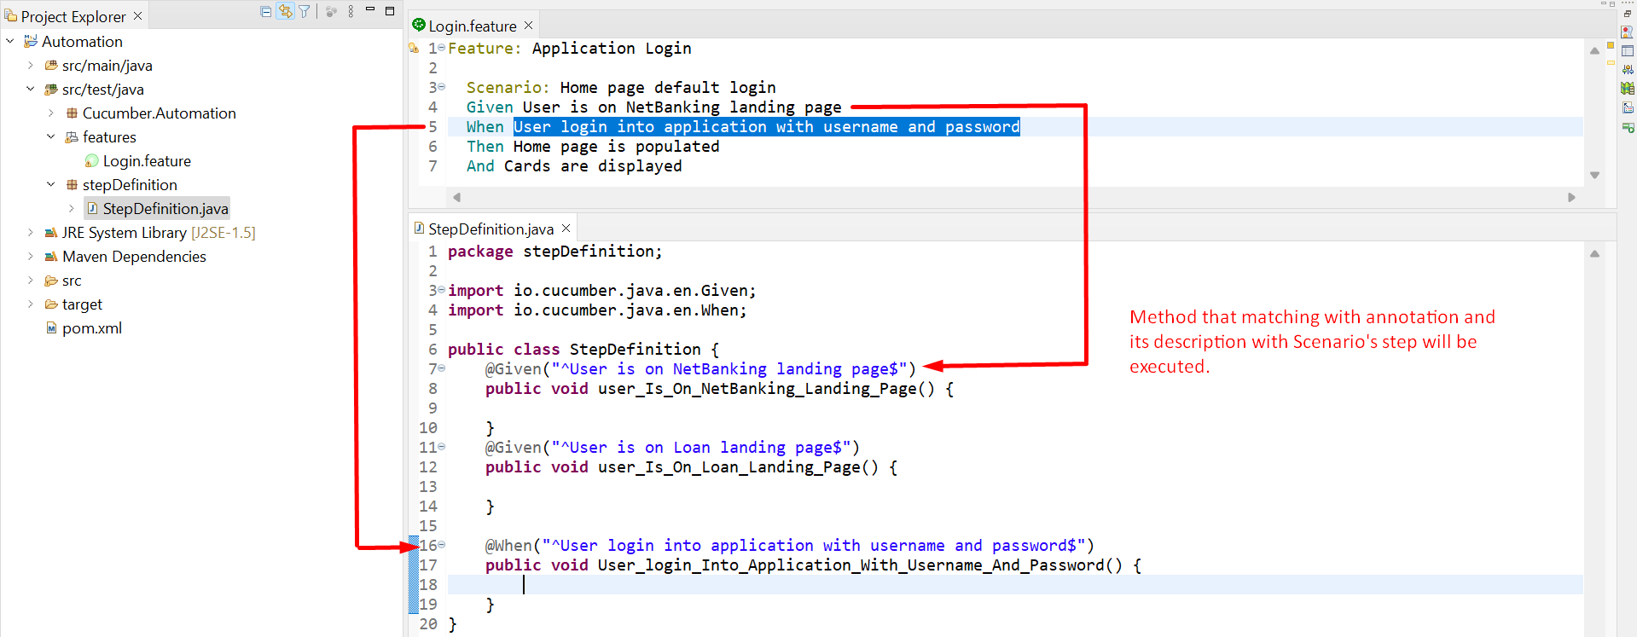
6. A picture containing diagram

   Description automatically generated
7. For any step in any scenario, if no matching Step Definition method, then Cucumber will throw an error.   
   So, in this way, we’re committing to develop and automate testing each and every line defined by our BA.